
SellVEL Admin

July 2012

Warning: The information furnished herein by Cyberweb Hotels LLC is proprietary and confidential to Cyberweb Hotels LLC and is not to be used, duplicated, published, or disclosed to any third party in whole or in part without permission from Cyberweb Hotels LLC.

Table of Contents
1 Introduction 2
1.1 Getting Started 2
1.2 Login 2
1.3 Troubleshooting 2
1.4 Administration Pages 3
1.5 Logging Out 3
1.6 Rearranging Fields 4
2 Dashboard 5
2.1 Booking Summary 6
2.2 Roomwise Booking Summary 6
2.3 Reservations Summary 6
3 Booking 7
3.1 Future Check-Ins 7
3.2 Today’s Check-Ins 7
3.3 Today’s Check-Outs 7
3.4 Total Check-Outs 7
3.5 All Reservations 7
4 Rooms 9
4.1 Adding New Rooms 10
4.2 Update Rooms 10
5 Rates and Availability 11
5.1 Quick Add Rates 11
5.2 Quick Block Rooms 12
5.3 Quick Open Rooms 13
5.4 Manage Daily Rates & Inventory 14
6 Discounts 16
6.1 Add Discounts 16
6.2 Update Discounts 17
7 Restrictions 18
7.1 Add/Update Length of Stay Restrictions 19
8 Reports 20
8.1 Report by Room Type 20
8.2 Report by Confirmation Number 20
8.3 Report by Check-In/Check-Out Date 20
8.4 Report by Booking Date 21
9 Settings 22

Introduction
This guide is meant to be used as a reference in setting up or updating your hotel information using the administrator interface provided. It is presumed that you already have a username and password. If you do not yet have user access, wish to schedule training, or have trouble with your login, please contact your Account Manager or Technical Support executive for assistance.

Getting Started
Open the link https://www.sellvel.com/booking/propertymanager in a browser window. Ensure that you have internet access.

Login
Enter your username and password. Then click Login to gain access to the administrator interface.

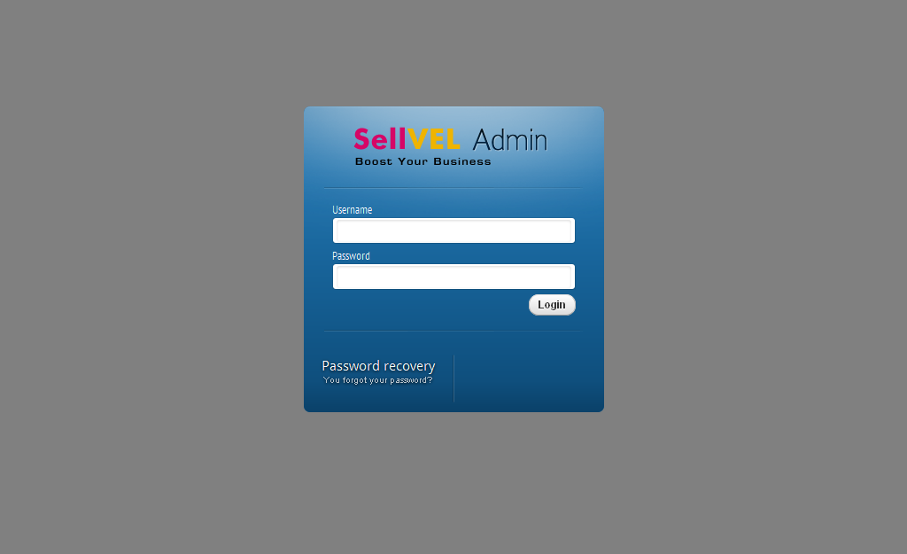

Troubleshooting
In case you have forgotten your password, click on “Password recovery”. Enter the email address associated with your username. You will, in a short while, get a mail from SellVEL to reset your password. In case of any other error, please check that you are entering the correct username and password.

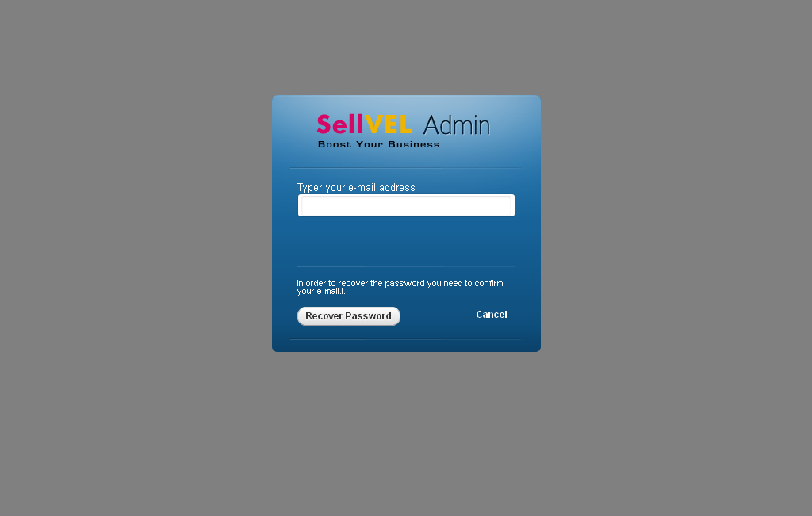

Administration Pages
Once you login, be sure to select the correct property website in case you have more than one property associated with your account. Use the drop-down menu on the blue bar for this purpose.

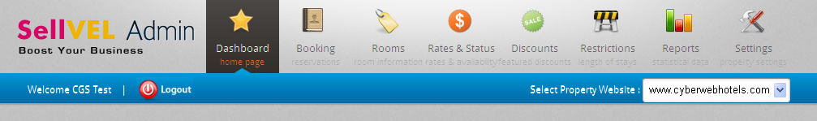

You will see various administration pages available to manage your property. Using these, you can control various aspects of the frontend (interface visible to your clients/customers) such as room rates, images of rooms, discounts applicable, restrictions on the length of stay, daily check-in and checkout data, etc. and see statistical reports related to reservations. By default, the “Dashboard” page is opened on logging in.

Logging Out
Once all the necessary work is over, please make sure to log out of the session to prevent unauthorized access to the administrator interface. Click the logout button on the blue bar. In addition, it is recommended to close the browser window/tab you were working in.

Rearranging Fields
Fields can be rearranged by dragging the grey ‘titles’ and placing the field at the desired location.

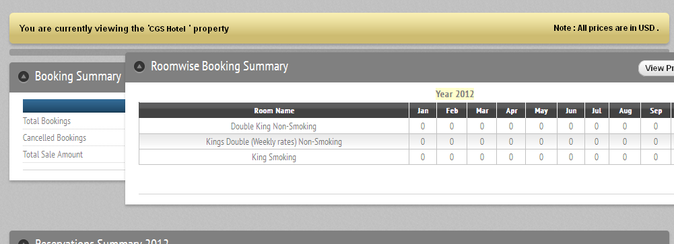

Dashboard
The Dashboard displays the overall summary of the bookings, which includes Booking Summary, Roomwise Booking Summary and Graphical Summary.

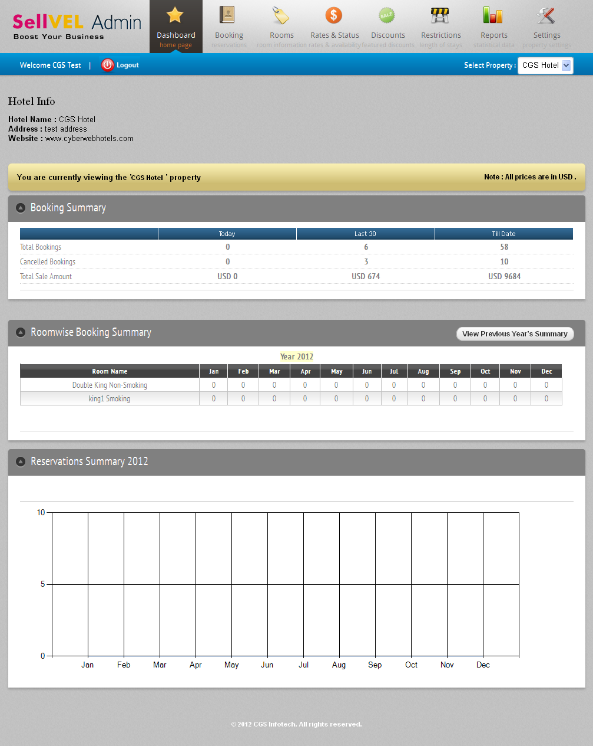

Booking Summary
You can see the total number of bookings executed (and cancelled) and the total sale amount for ‘today’, the last 30 days and aggregate (till date).

Roomwise Booking Summary
You can see the monthly occupancy of different types of rooms for the current (and previous) year.

Reservations Summary
Shows a graphical representation of all bookings executed in the current year.

Booking
To get started, click “Booking” at the top of the page. This screen displays bookings made through the website. Select the appropriate filter in the drop-down menu to view the corresponding bookings.

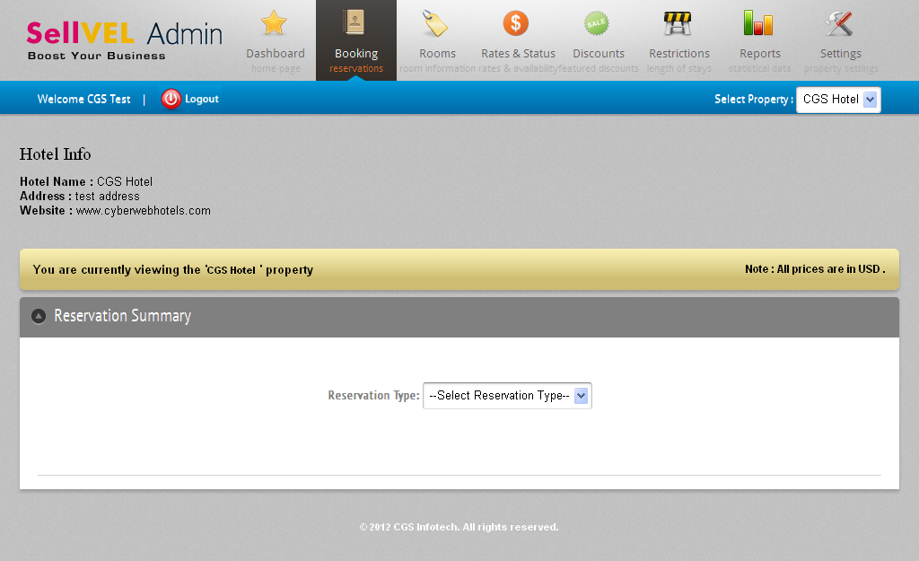
Filters

Future Check-Ins
Here you will see a list of bookings arriving in the future.

Today’s Check-Ins
Here you will see a list of bookings that are arriving today.

Today’s Check-Outs
Here you will see a list of bookings that are departing today.

Total Check-Outs
Here you will see a list of bookings that are already cleared.

All Reservations
Here you will see list of all bookings, regardless of current status.
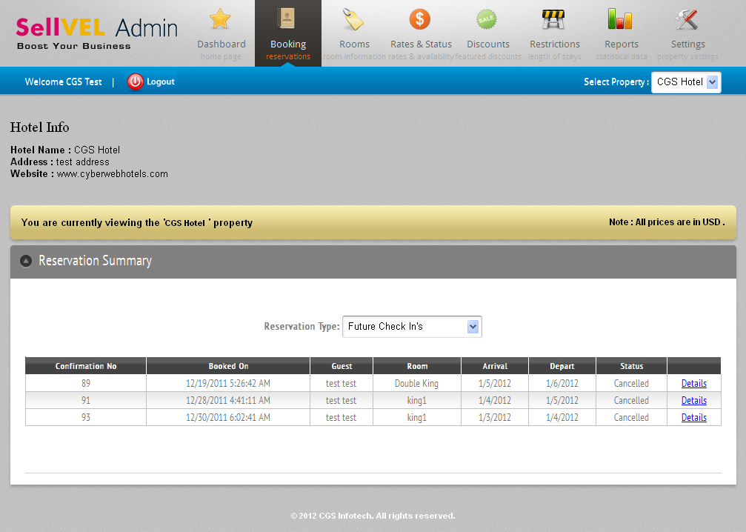
Click on “Details” to see the information about a booking.
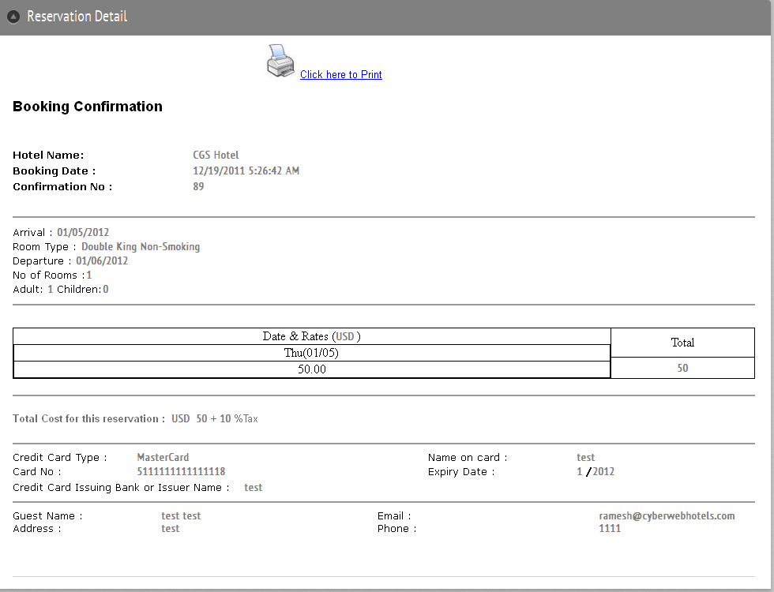

Rooms
To get started, click on “Rooms” at the top of the page. You will see a tabular list of all different types of rooms (in the order in which they were created by you). You may edit the details of an existing room type (click “Edit Room”) or create a new one (click “Add New Room”).

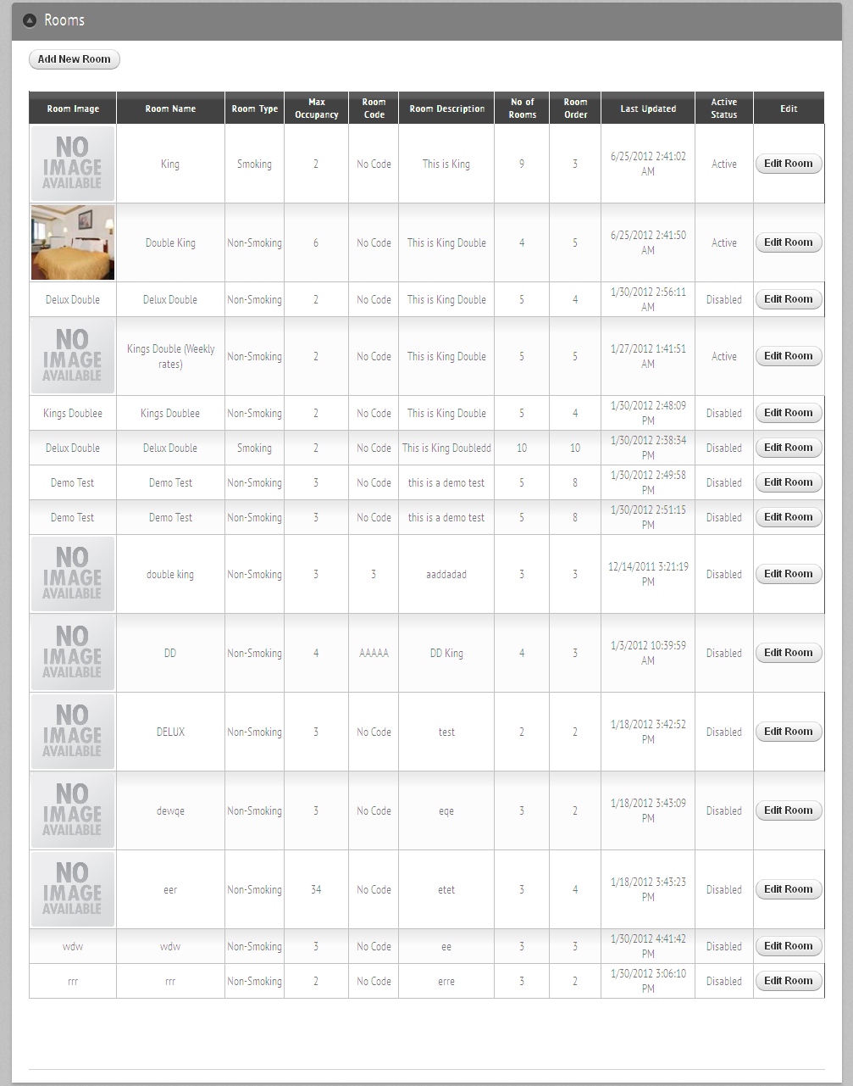

Adding New Rooms
- Enter the room name (e.g. King Room, King Suite).
- Select room type from dropdown (Smoking/Non-Smoking).
- Enter description including the amenities of that room.
- Enter number of rooms to be open for booking via SellVEL.
- Enter max occupancy (number of guests allowed in a room).
- Enter room code (if applicable).
- Enter the order (position) in which you want to display rooms to guests.
- Browse to an image of the room for guests to see beforehand.
- Click the “Add New Room Type” button.

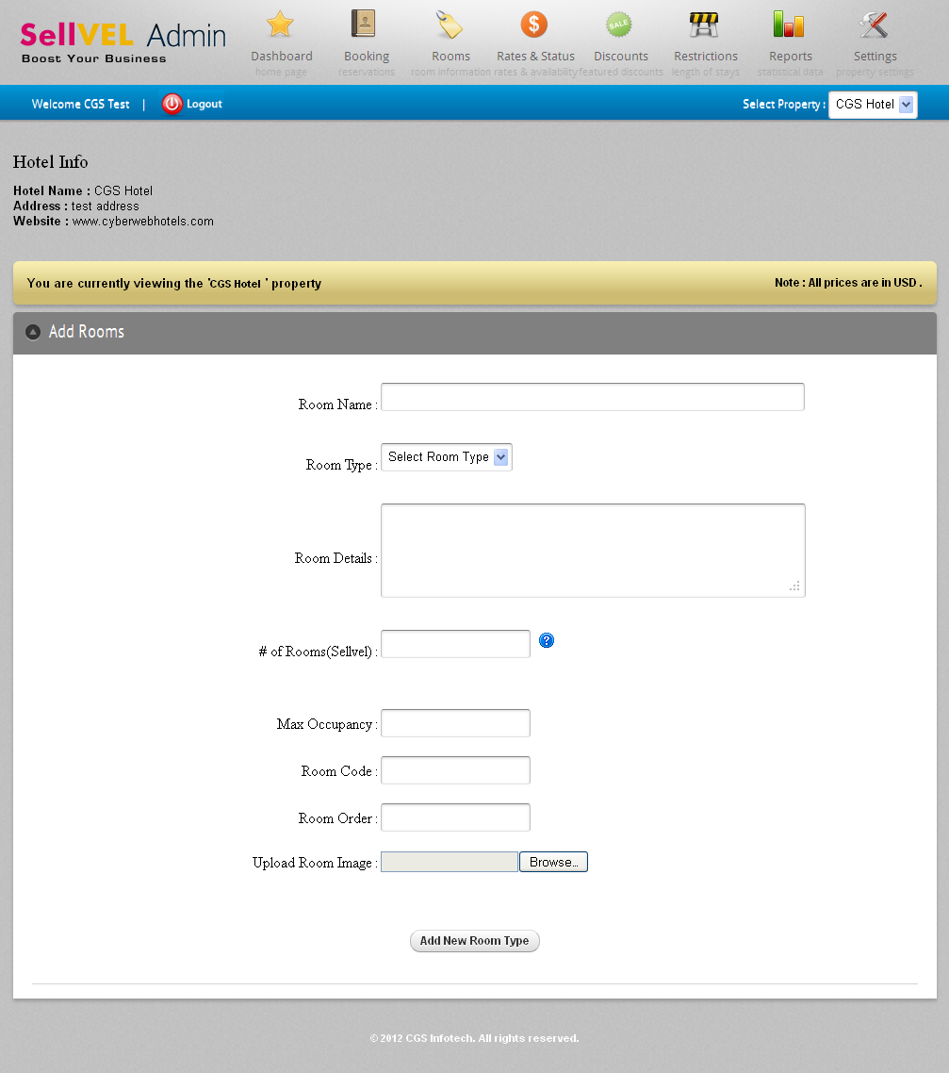

Update Rooms
Follow the same procedure as that of adding new rooms. The only difference is a check box to make the room active/inactive, i.e. available or not for booking. After making the required changes, click the “Update Room” button.

Rates and Availability
To get started, click on “Rates & Status” at the top of the page.

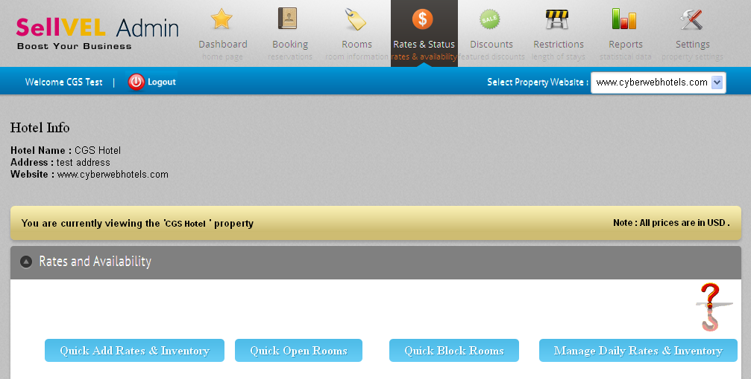
Hover for Help

Quick Add Rates
Click on “Quick Add Rates” and follow the procedure –

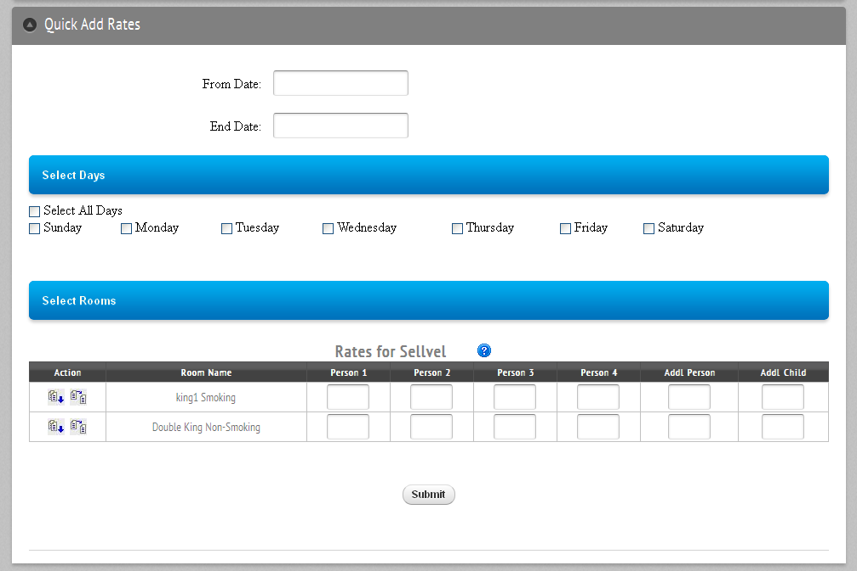
- Select the period for which the rates will be valid. To make changes for one day only, the start and end date must be the same.
- Select the days for which the rates must be applied. (Any days of week that are checked will have rates applied; any days that are unchecked rates will remain unchanged.)
- Enter the rates. Person 1 indicates the rate for single person, Person 2 indicates rate for 2 people, Person 3 indicates rate for rate for 3 people, Person 4 for 4 people. “Addl Person” indicates the additional charge for additional adult. “Addl Child” indicates the rate for an additional child. Enter 0 if any of these are not applicable.
- Click the “Submit” button to save the changes.

Quick Block Rooms
Click on “Quick Block Rooms” and follow the procedure –

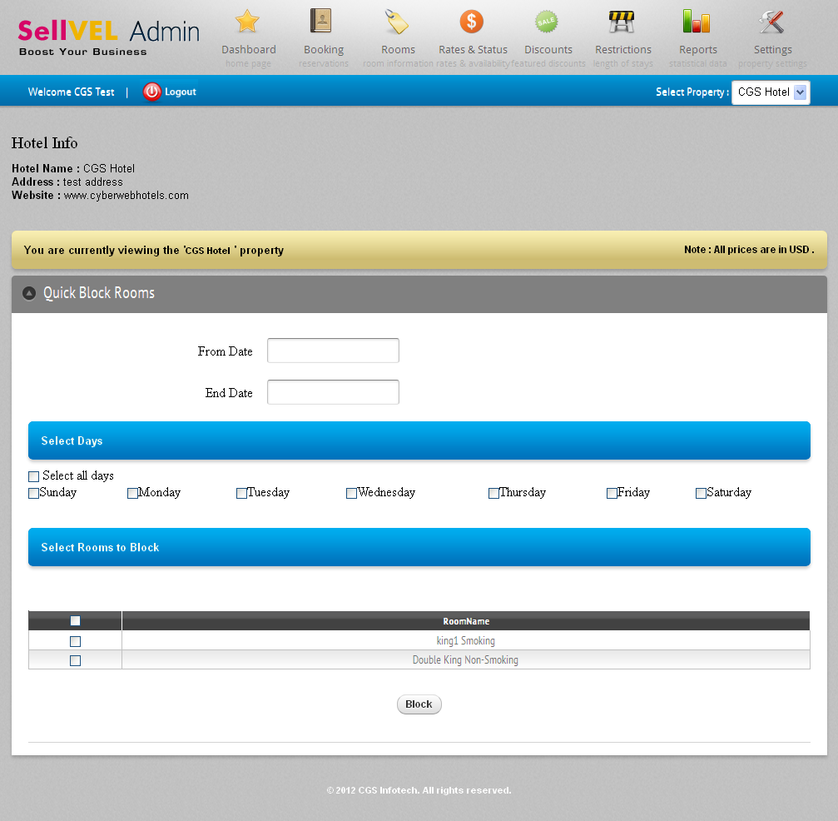

- Select the period for which the rooms must be closed. To make changes for one day only, the start and end date must be the same.
- Select the days for which closing must be done. (Any days of week that are checked will have closeout applied; any days that are unchecked will remain unchanged.)
- Select the rooms to be closed. Click on checkbox to apply close out. To set for all rooms click checkbox at the top.
- Click the “Block” button to apply the update and block the room(s).

Quick Open Rooms
Click on “Quick Open Rooms” and follow the procedure –

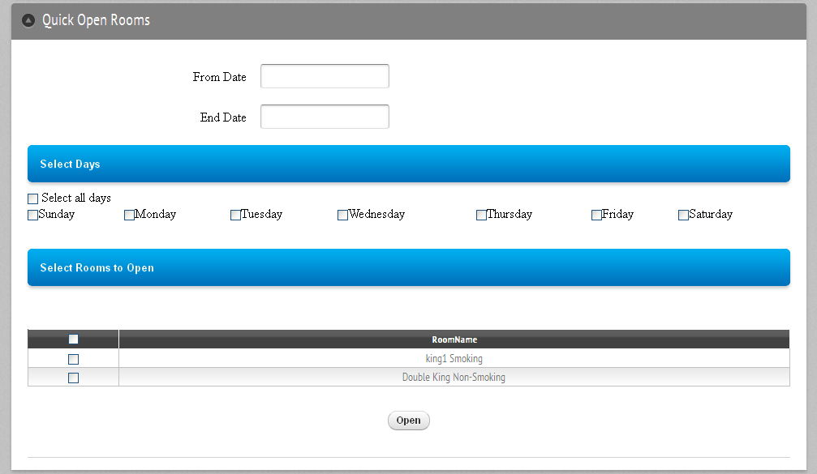

- Select the period for which the rooms will be open. To make a change for one day only, the start and end date must be the same.
- Select the days for which the room will be open. (Any days of week that are checked will have open room applied; any days that are unchecked will remain unchanged.)
- Select the rooms to be open. Click on checkbox in front of every room to open rooms. To set for all rooms click checkbox at the top.
4) Click the “Open” button to apply the changes marked.

Manage Daily Rates & Inventory
Click on “Manage Daily Rates & Inventory” and follow the procedure –

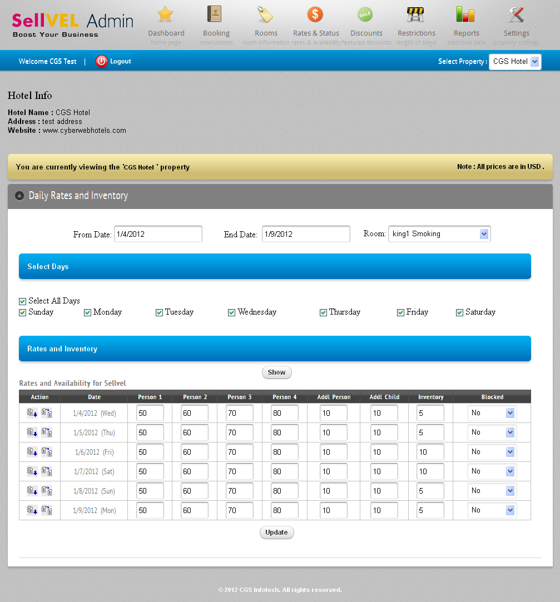

- Select the period. To make changes for one day only, the start and end date must be the same.
- Select the room using the drop-down menu.
- Select the days of week.
- Click the “Show” button. A grid will be displayed for the date range selected, showing the daily rates and inventory data.
- Enter/Change the rates, inventory and block status for each applicable date into appropriate textbox and drop-down menu.
- Click the “Update” button to save the information/changes.

To make all the values (rates, inventory, blocked status) below a particular row identical to that row, click the “Same for all Rooms” button as highlighted in the image above.

Discounts
To get started, click “Discounts” at the top of the page. Discount plans can be set (such as AAA, AARP, Military, etc.) as per your requirements.

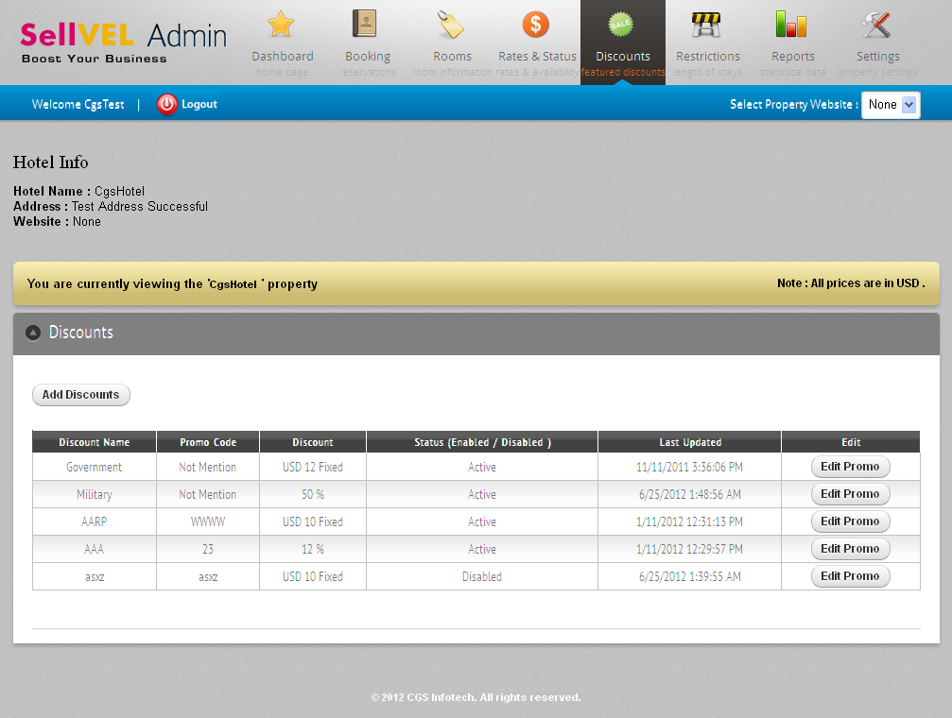

Add Discounts
Click the “Add Discounts” button and follow the procedure given below–

- Enter the discount name (e.g. AAA, AARP etc.).
- Enter a discount code, if applicable.
- Select the type of discount to apply, i.e. Fixed or Percent. If ‘Percent’ is chosen, the discount on standard rates will be calculated as percentage of the total. If ‘Fixed’ is chosen, the discount on the standard rate will be calculated as a flat dollar, i.e. in absolute terms.
- Enter the discount value (e.g. 10). It must be strictly numeric.
- Click “Submit” to apply the discount.

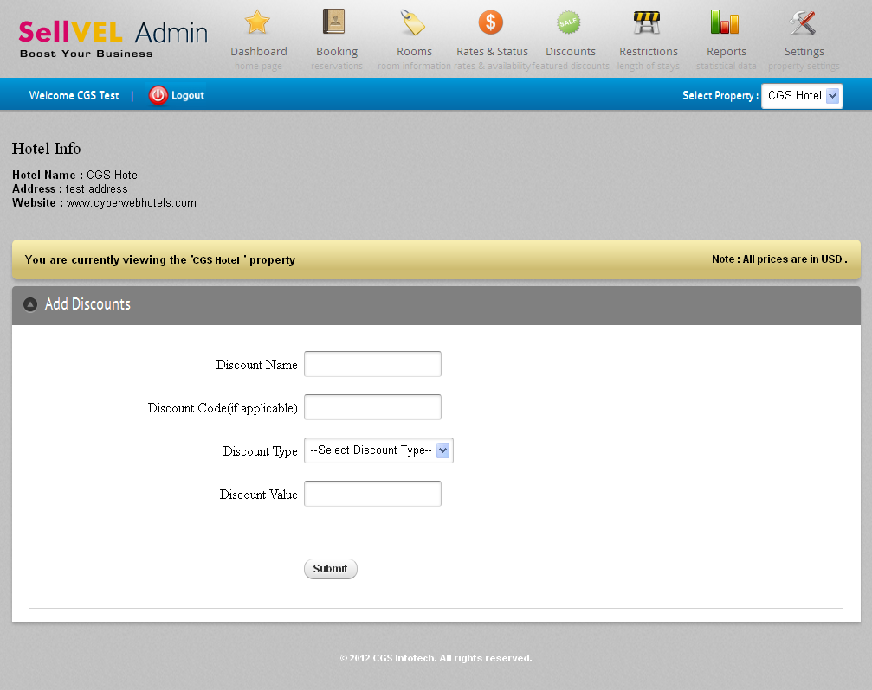

Update Discounts
Click “Edit Promo” and follow same procedures as that of Add Discounts. Click the “Status” checkbox to activate (or deactivate) the discount. Using this, you can show/enable (or hide) the discount in the frontend (visible to your guests/clients).

Restrictions
Length of Stay Restrictions allows you to set conditions on the duration of guests’ stay. This functionality can also be used for setting up extended stay and putting up price offsets for extended stay. To get started, click “Restrictions” at the top.

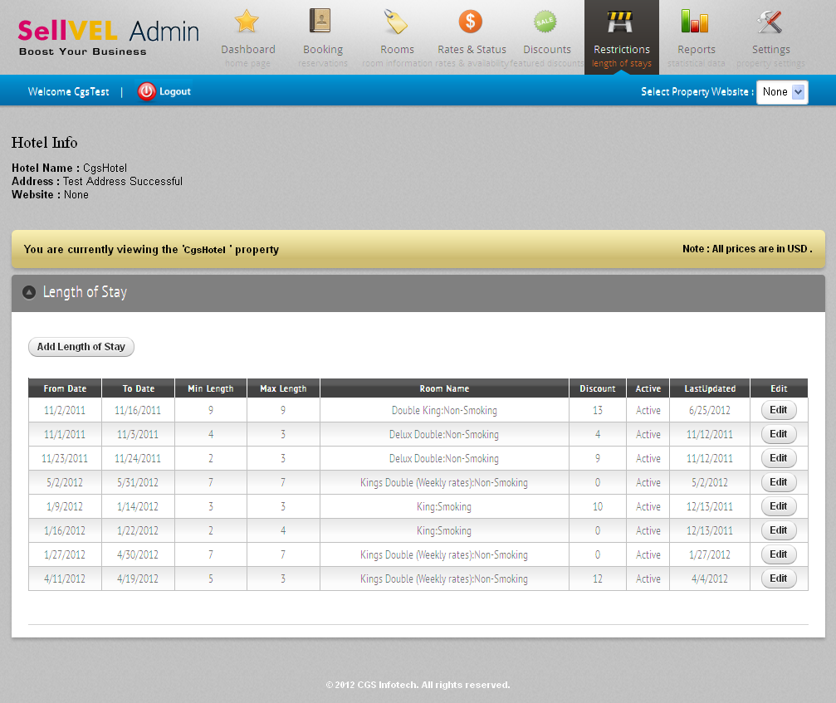

Add/Update Length of Stay Restrictions
Click the “Add Length of Stay” (or “Update Length of Stay”) button and follow the procedure given below to add (or modify) a new (or existing) ‘Length of Stay restriction’ –

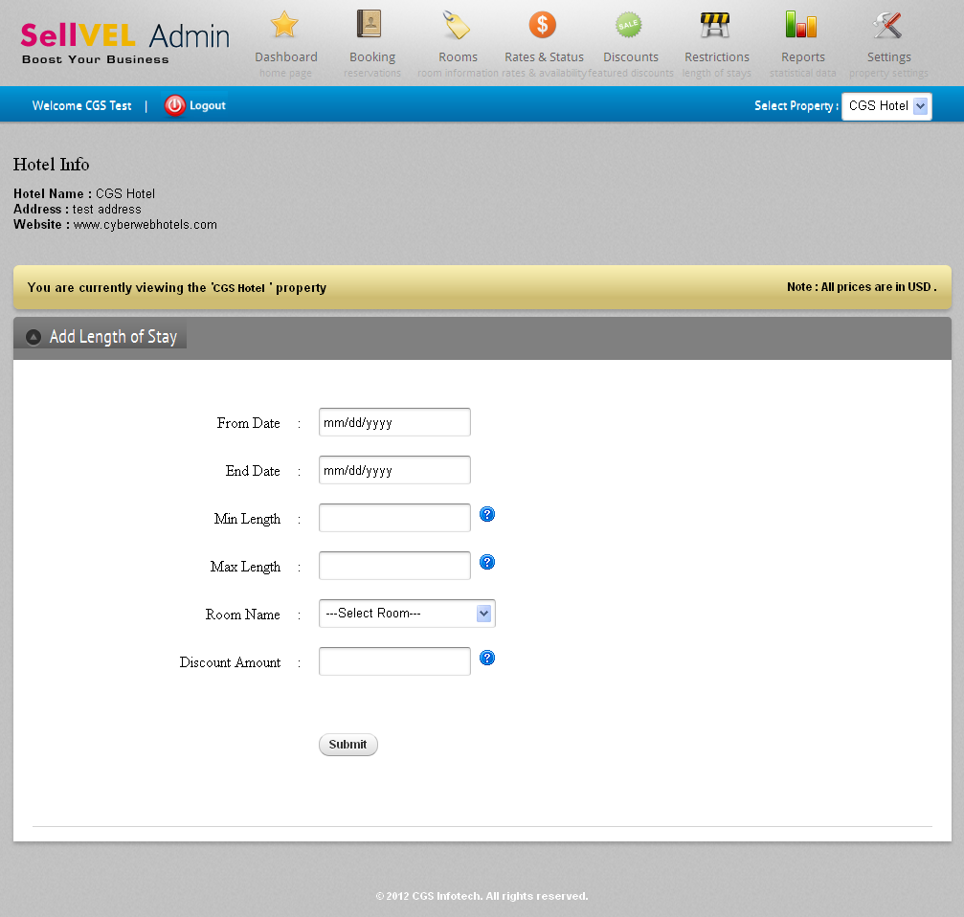

- Select the period for which restrictions are to be applied.
- Enter the minimum duration (in the Min Length field) to apply minimum nights stay restriction. (Optional)
- Enter the maximum duration (in the Max Length field) to apply maximum nights stay restriction. (Optional)
- Select the room(s) for which the restrictions are to be applied.
- Enter discount value (flat dollar only) if you wish to give discount for selected period (date range) or if the booking matches any restriction criteria. (Optional)
- Click the “Submit” button to apply the restriction.

Reports
Report functionality allows tracking of the reservation and reservation statistics.

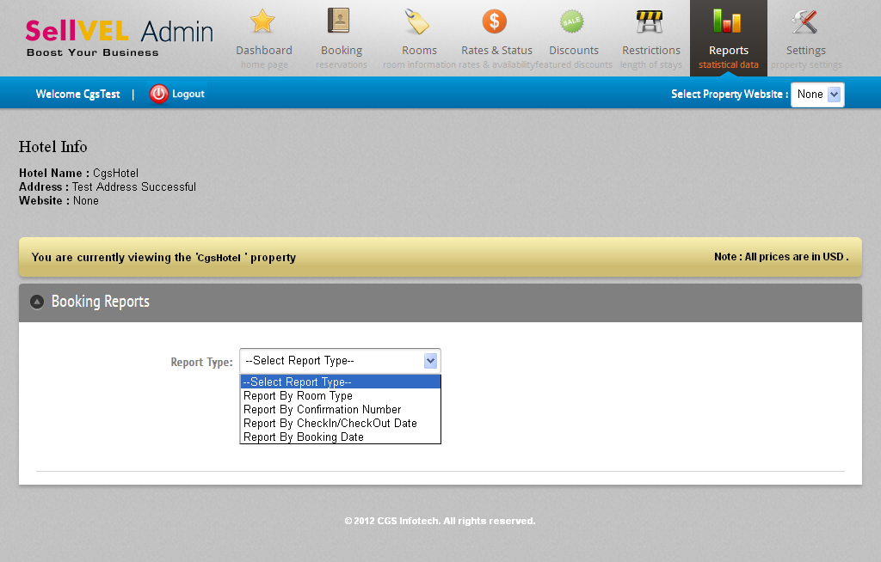

Report by Room Type
The reservation report by room type will provide a detail list of reservations based on room type selected. Click the Show button to see the list.

Report by Confirmation Number
The reservation report by confirmation number will provide the details of reservation of confirmation number entered. Click the Show button to see the list.

Report by Check-In/Check-Out Date
The reservation report by check-in/check-out date will provide a detail list of reservations based on check-in and checkout date and date range selected. Check-In and Check-Out Date must be between the dates ranges selected. Click the Show button to see the list.

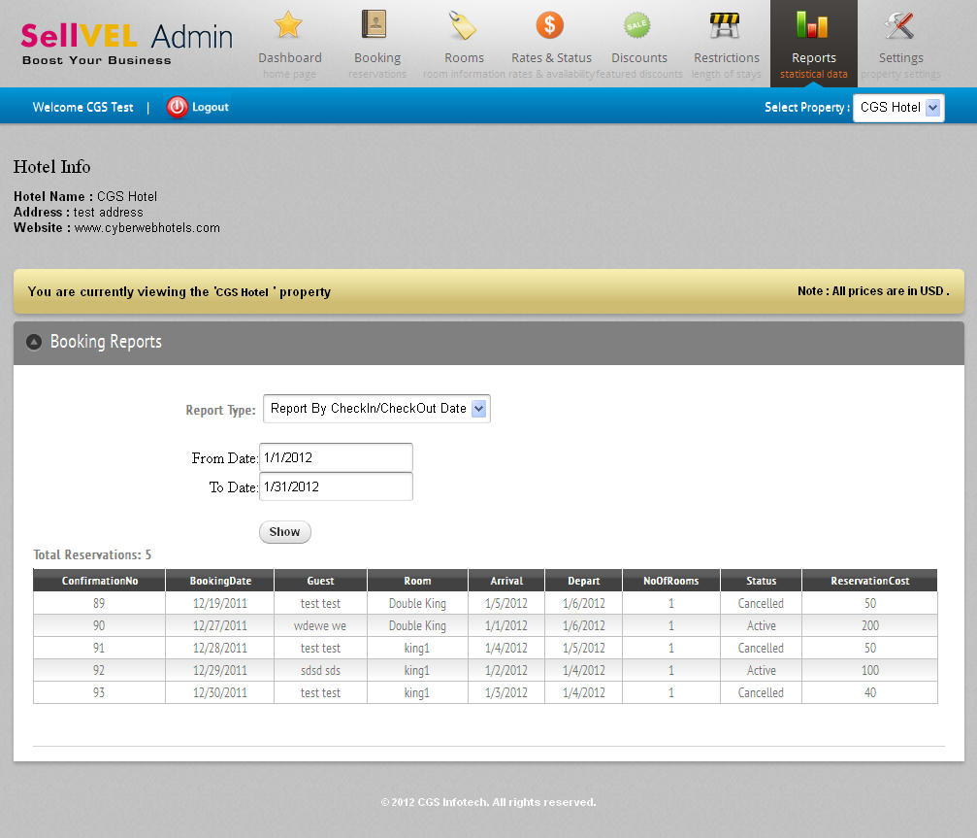

Report by Booking Date
The reservation report by booking date will provide a list of reservations based on the booking date of reservation and for period (date range) selected. Click the Show button to see the list.

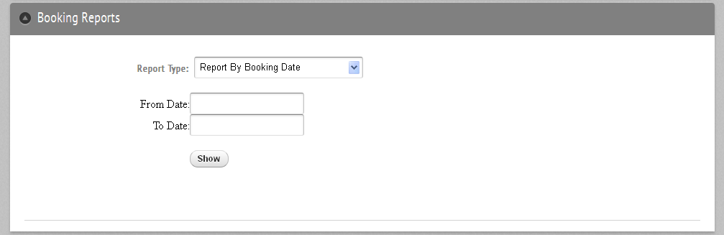

Settings
To get started, click “Settings” at the top of the page. You can set or modify the password, property details including the hotel name, fax, phone number, cancellation policy, tax rate, etc.



